Film studies assignment

The shawshank redemption

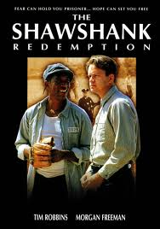
Job Title: | Description | Example from the shawshank redemption!
Director | Decides how the film should look over all and the artistic side of the film. | Frank Darabont
Producer | In charge of funding and advertising | Liz Glotzer  David V. Lester  Niki Marvin
cinematographers | In charge of all the cameras and lighting. | Tim L. Amstutz
Editor | Takes footage and makes it into the actual film. | Richard francis bruce.
Costume design | Creates and designs the costumes for the film. | Elizabeth mcbride

Camera shots.
This refers to the way the cameras are positioned to create certain effects.
Close up
The close up shot usually show one person .It is used to isolate important that moment in the film. It can make the character seem like they are on their own even if there are lots of people around them.
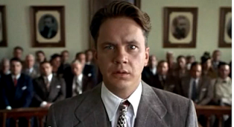
Mid angle
The mid angle shot shows characters from the waist upwards. It often shows more than one character and gives a wider view of the situation without showing the parts of the set not in use at the time.
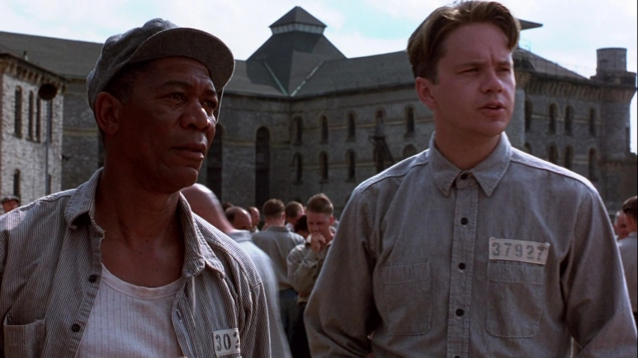
High angle
The High angle shot shows the character from an angle above their head. It is often used to show a character’s vulnerability.
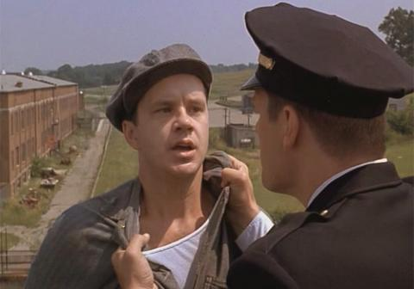

Low angle
This makes the audience feel that the character is powerful and confident.
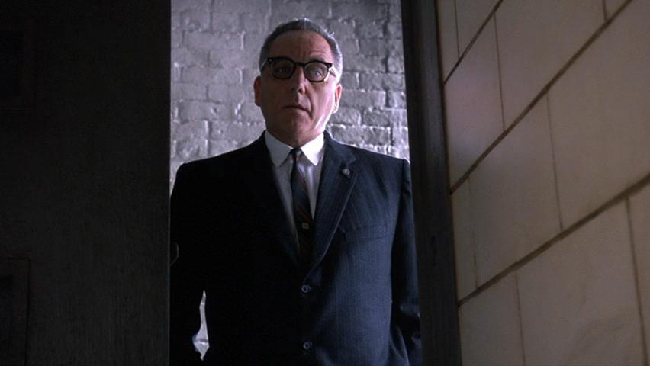
Wide angle
This shows the setting. It can also show alot of characters at once.
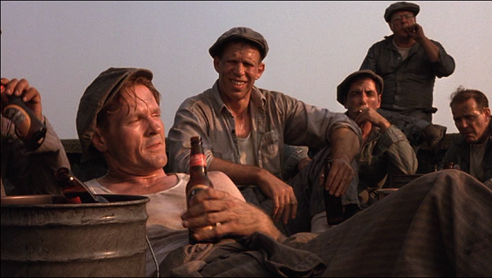

Film genres

Comedy | Happy Gilmore | 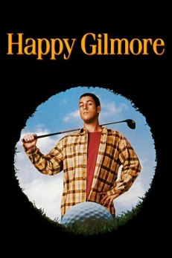
Horror | Saw | 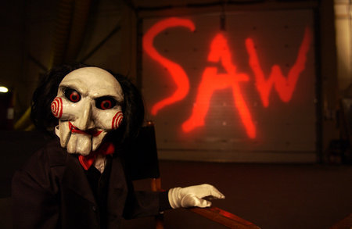
Action | Die hard | 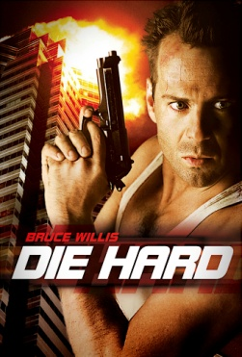
Western | Austrailia | 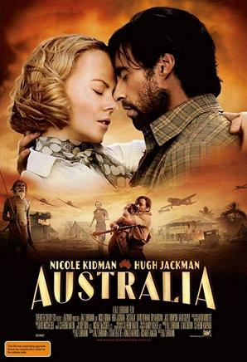
War | Saving private ryan | 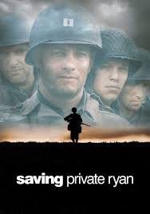
The effect of music on a movie.

Music in films is used in many different ways in different types of movies. This is often effected by the genre. For example in a thriller or Horror film the music is loud and intense or builds up slowly to create tension whereas in a romantic film the music is smoothe.
In the shawshank redemption andy Dufresne ( Tim robbins) plays ‘the marriage of Figaro’ by Mozart. This song gives the prisoners a sence of freedom.
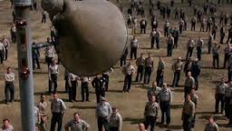

Mise-en-Scene
Mise-en-scéne is an expression used to describe what appears in front of the camera including the set, the props, the actor(s), the costumes and the lighting. Each director usually has a certain style in his/her movie.
Set in the grounds of a prison

Their clothing, along with the bench and their surroundings are all very grey and boring. This reflects what its like to be inside a prison everyday.
Everyone in the shot is wearing the same clothes, which shows they are all seen and treated as the same; a bunch of criminals.
The fact that the character of Andy Dufresne is smiling is a sharp contrast to the rest of the image, its as if he doesn’t fit in with his surroundings.
Red (right) is sitting above Andy to show dominance. Andy is new to the prison and is therefore not as well respected as Red who has been at the prison for years. Red is much older than Andy and this also shows that he is the dominant figure of the two.
The two characters are in focus whilst the background is blurred shows that all the attention should be on Andy and Red. Also, they are in the centre of the image, another reason that all the attention should be on them.

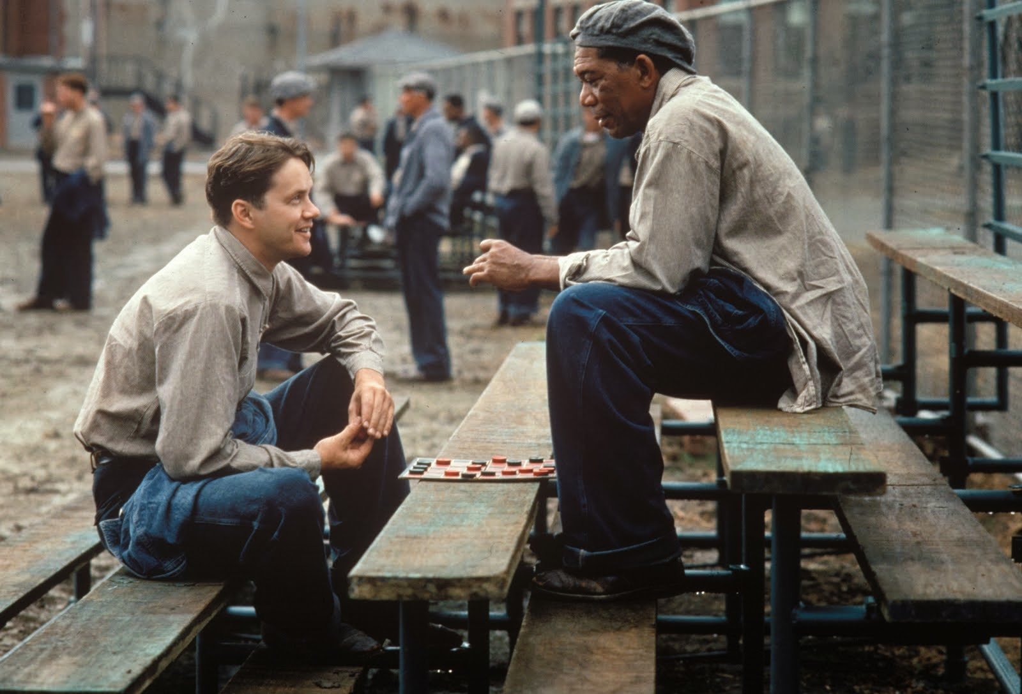
Actors and acting

I think that all the actors were excellent in the shawshank redemption. I would not change one of them which really says something about the movie.
Tim Robbins 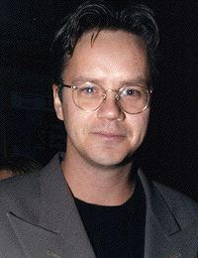
Morgan Freeman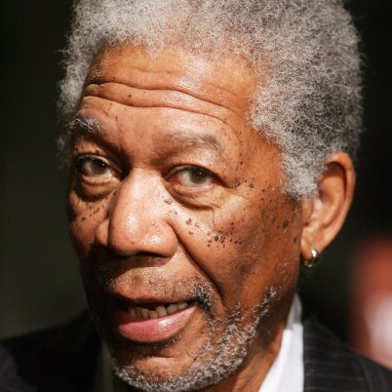
Bob Gunton 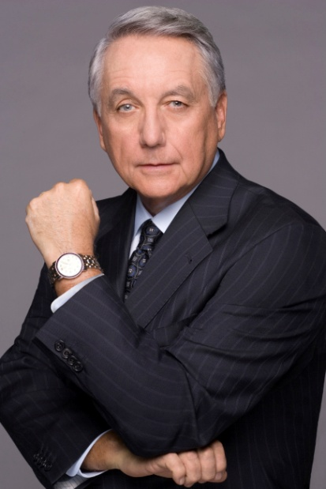
Special effects
Special effects are ways that we can show whole new. There would be no way to make a film about magic or alien spaceships etc without visual effects because we can’t film them for real.
There were no special effects in the movie the shawshank redemption.

Costume
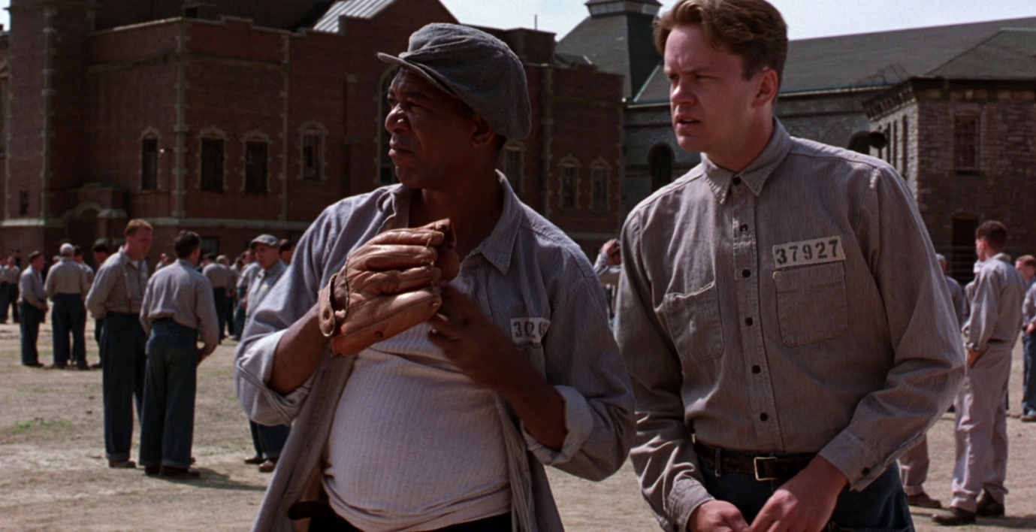

Early on, Andy keeps his uniform very proper and business like. Red is clearly the opposite.
Every uniform draws from a core set of prison issue items, but with different levels of faded, hats, suspenders, and other touches that make them all look quite unique.
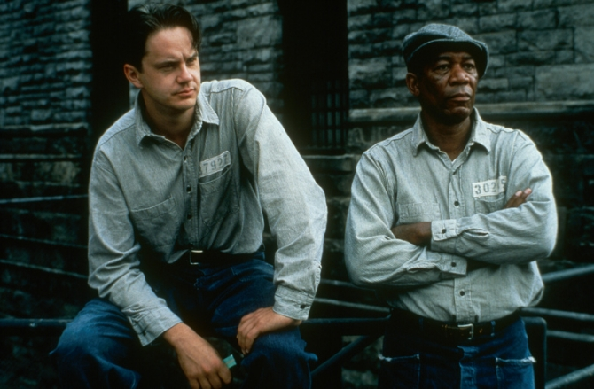
Towards the end, Red and Andy seem to almost mirror each other.

Cinematography and artistic design
Cinematography is the art of shooting film. The cinematographer makes the decisions on how to shoot a scene, from where and what lighting will be used. They make artistic design choices while filming. The cinematographer of the shawshank redemption is Roger Deakins.
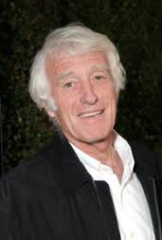
My Review of the film
Plot summary:
Bank Merchant Andy Defrene is convicted of the murder of his wife and her lover, and sentenced to life imprisonment at Shawshank prison. Life seems to have taken a turn for the worse, but fortunately Andy befriends some of the other inmates, in particular a character known only as Red. Red is man who knows how to get things and Andy uses that to his advantage by getting items off him. But Andy is a smart man and uses his time wisely. He dug out a hole that led him out of the prison and he escapes. He also takes all the wardens money.

Things I liked:
I thought that all the actors were excellent. The plot has a really good ending. The way the prison was corrupt made it much more interesting.

Things I didn’t like:
I don’t like how we don’t find out what happened to andys other friends who were still in prison.

Rating: I would give the shawshank redemption a 10/10.

