SAMPLE FILM STUDIES ASSIGNMENT
Contents Page

Contents: | Page:
People in the Film Industry |  | 3-4
Camera shots |  | 5-7
Film Genres |  | 8
Music in Films |  | 9
Mise-en-scene |  | 10
Actors and Acting |  | 11
Special effects |  | 12
Cinematography and artistic design |  | 13
Make-up and hair design |  | 14
Sequencing |  | 15
Film Review: ‘The Lord of the Rings: The Return of the King’ |  | 16

People in the Film Industry
Job Title: | Description: | Crew of ”the Lord of the Rings: Return of the King”
Director | In charge of the artistic side of film making and how the film should look overall. | Peter Jackson
Producer | In charge of the non-artistic side of film-making e.g; funding, distribution and advertising | Peter Jackson, Barrie M Osborne, Fran Walsh
Foley artists | Foley artists reproduce everyday sounds that are added in the post-production stage of film editing. This is a good example: http://www.youtube.com/watch?v=UNvKhe2npMM | Simon Hewitt, Phil Heywood, Paul Huntingford and Adrian Medhurst
Cinematographers | In charge of the cameras and lighting and responsible for making decisions in relation to technical issues and artistic design | Andrew Lesnie
Editor | The editor takes the raw footage and shots of the film and creates sequences to create a finished picture. It is one of the most challenging jobs in film-making. | Jamie Selkirk
Costume Designer | Creates and designs the costumes for the film. | Ngila Dickson and Richard Taylor
Screen writers | The screenwriter writes the script or dialogue of a film. | Fran Walsh, Philippa Boyens and Peter Jackson
Composer | Writes the music for the film. | Howard Shore
Set designer | Designs sets for the film | Dan Hennah and Alan Lee
Casting Director | Organises the casting of actors and extras in the film during pre-production | Victoria Burrows, Amy Hubbard, John Hubbard, Liz Mullane and Ann Robinson
Continuity arranger | Makes sure that there are no errors in props, costumes and scenes in continuity and that from shot to shot, everything looks the same.
Hair and Make-up department | Uses prosthetics, hairstyling, wigs and make-up to create a character’s appearance in a film | Margaret Aston, Rick Findlater, Debbie Fitzpatrick, Vance Hartwell, Nancy Hennah, Steve Hopgood, Mark Kinaston-Smith, Peter King, Jessica Lalande, Davina Lamont, Tami Lane, Louise Leonard, Vivienne MacGillicuddy, Catherine Maguire, Emma Moncrieff, Angela Mooar, Peter Owen, Elizabeth Pick, Ivana Primorac, José Luis Pérez, Kerryn Roberts, Allie Rutherford, Janine Schneider, Lenore Stewart, Gail Taylor, Richard Taylor, Tera Treanor, Caroline Turner, Noreen Wilkie, Gail Wilson, Jeremy Woodhead, Sarah Weatherburn and Laurelle Ziento
Special effects company | In charge of creating special effects that includes mechanised props, Make-up, props, scale models, pyrotechnics, scenery and creating atmospheric effects e.g. weather effects | Weta Workshop and Weta Digital
Stunt coordinator | Arranges the casting and performance of stunt performers. | Kirk Maxwell and George Marshall Ruge,
Executive producer | Either the person who bought the rights to the movie or the person representing a financial investor in the film. They can have a lot of creative control over the film or very little | Michael Lynne, Mark Ordesky, Robert Shaye, Bob Weinstein and Harvey Weinstein
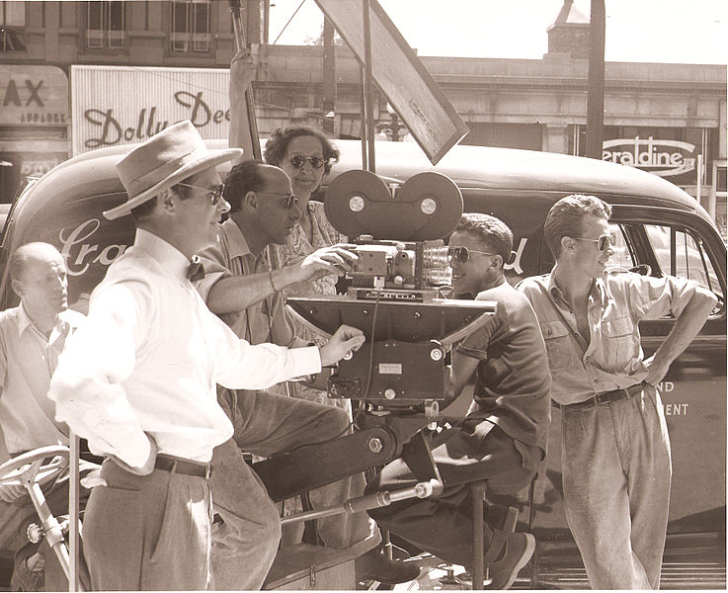

Camera shots
Camera shots refer to the positioning of camera angles in a movie to create different effects. For example: to make someone look powerful or weak or to highlight certain features of a scene.
Close up:
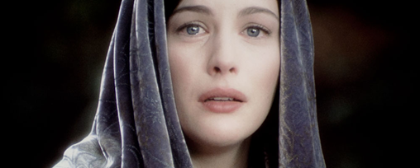
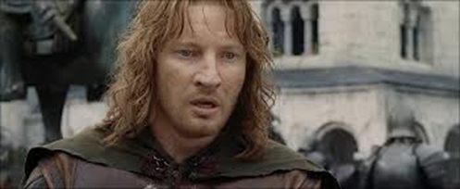
The close up shot usually show one person or part of a person. It is used to isolate important features or emotions that are important at that moment in the film. It can make the character seem like they are on their own even if there are lots of people around them.
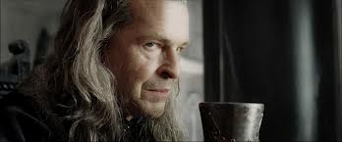
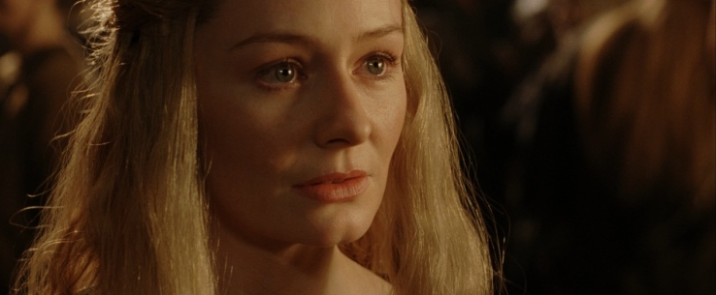
All of the above examples show powerful emotions and the characters are feeling isolated from everyone else. In the top left, Faramir is burdened with his brother’s death and his father’s madness. In the top right, Arwen sees an image of a future that she wishes to be true. In the bottom left, Lord Denathor, addicted to power and greed and grieving because of his favourite son’s death, is sinking into madness. In the bottom right Éowyn is dealing with her unrequited love for Aragorn and her uncle’s decision to leave her in charge of Rohan.

Mid angle:
The mid angle shot shows characters from the waist upwards, usually used at emotionally neutral moments or to allow hand gestures or small movements to happen. It often shows more than one character and gives a wider view of the situation without showing the parts of the set not in use at the time.
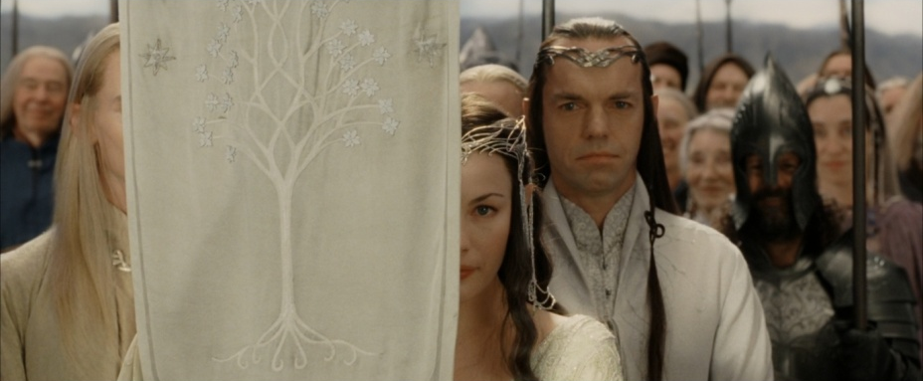
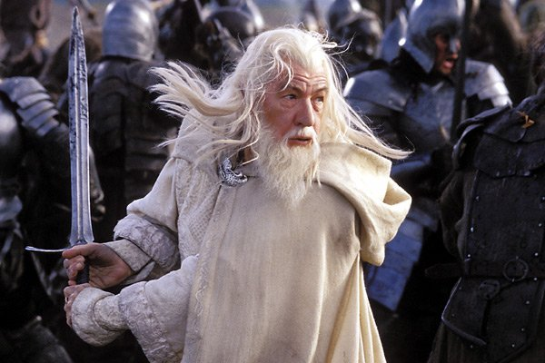
The shot on the left allows enough room for hand gestures and sword swings to be in shot. The shot on the right allows more than one character to fit on screen.
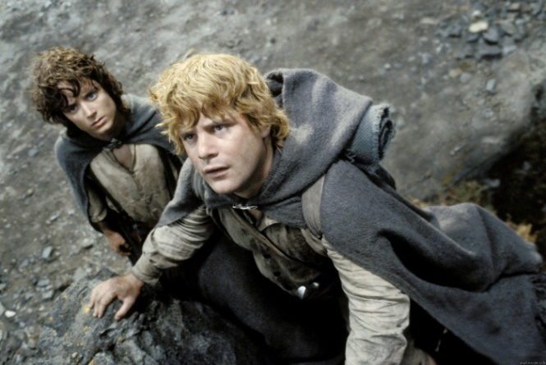
High angle:
The High angle shot shows the character(s) from an angle above their head. It is often used to show a character’s vulnerability, fear or low self-confidence. In the example below, Frodo and Sam are afraid and vulnerable because they are lost.
Low angle:
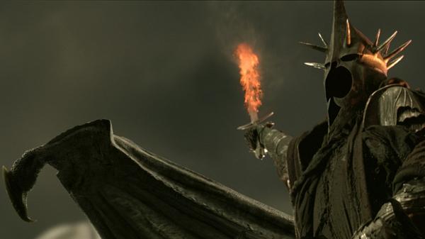
The Low angle shot shows the character(s) from an angle below them. This makes the audience feel that the character is powerful and confident. In the example below, the Witch King is an extremely imposing and very powerful enemy and the angle makes him look very formidable.

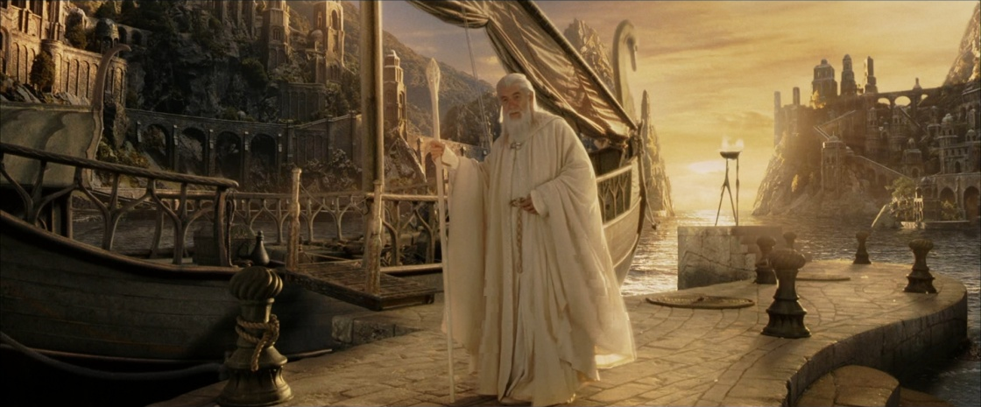
Wide angle:
The wide angle shot shows characters fitted to the screen so that you can see all of their body and parts of their surroundings. It can be used to show the setting around them but mostly it shows the character and allows room for actors to use big actions such as running or riding a horse on the screen.
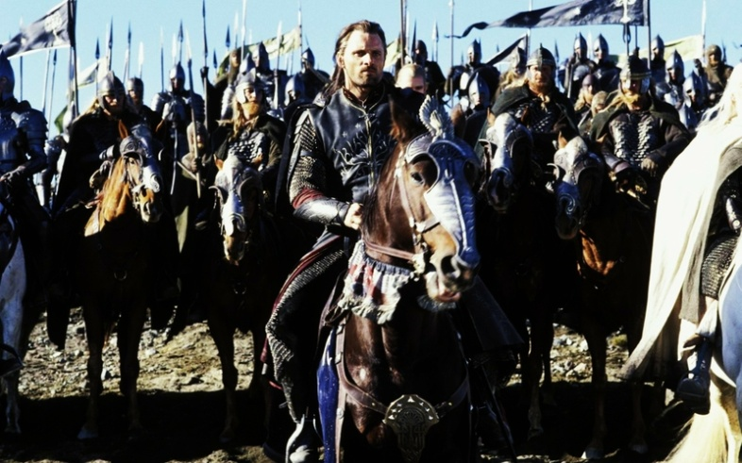
The two examples shown below have the main character fully within the camera shot. The first one shows Aragorn and allows the viewers to see part of his army behind him and the second shot is of Gandalf and it shows the harbour all around him and allows us to see the ship directly beside him.

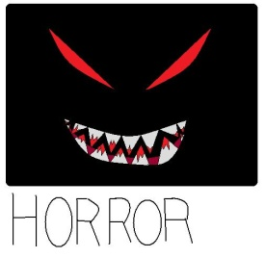
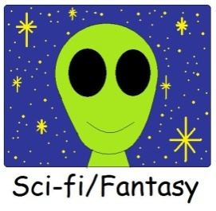
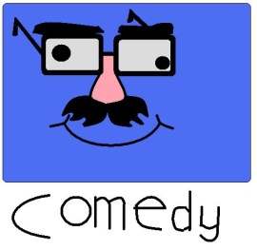
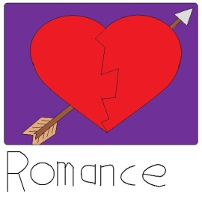
.Film Genres.

A film genre is a way of categorising films based on their content

Adventure – An adventure film usually focuses around a journey where something unexpected happens or where there is a lot of danger and challenges. This genre is often combined with Action to make a more rounded storyline. Examples include The Indiana Jones movies and The Lord of the rings: Return of the King

Romance – A film that focuses around the romantic relationships of charachters. There is usually more emphasis on charachter development and storyline than action. Examples include Jane Eyre, Pride and Prejudice and 500 Days of Summer

Horror – Horror films focus on surprising and scaring the audience by using suspense, tension and gore. They vary from being graphic and violent to being full of suspence and anticipation. Examples include the Excorcist films and the Saw franchise

Musical – Films that focus on music and have charachters break into song to express their emotions. Often times these are adaptations of books or musicals on Broadway or the west end. Examples include Les Misérables and Mamma Mia

Comedy – Movies that focus on making the audience laugh. This is a very broad genre as it can be done using many different comedy techniques for example; situation comedies and dark humour. Examples include The Simpsons Movie and My Cousin Vinny

Other Genres include: Western, Thriller, Animated, Art, Apocalyptic, Children’s, Period Drama, Drama, Fantasy, Science-fiction

Music in Film
Music in films is used in many different ways in different types of movies. This is often effected by the genre and/or the ideas and plotline. For example in a thriller or Horror film the music is loud and intense or builds up slowly to create tension whereas in a romantic film the music is smooth and orchestral reflecting the mood of the relationship.
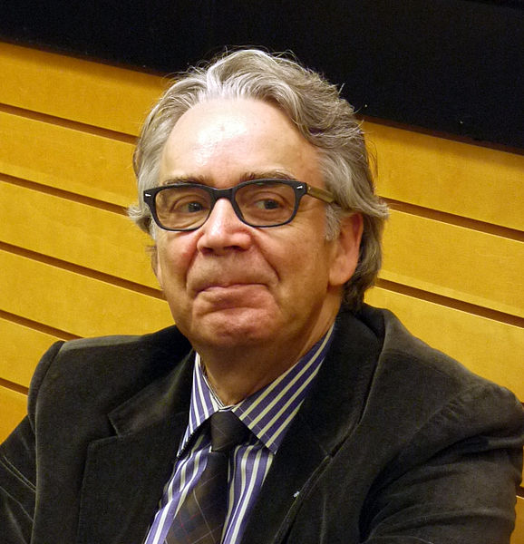
Music in “The Lord of the Rings: Return of the King”
The music in “The Lord of the Rings: Return of the King” is an original score composed by Howard Shore. The movie itself has a very broad set of moods and settings so there is a lot of variation in the music. For example over the trilogy of films there are wars, mysterious forests, little towns, huge towers, proud cities and even a volcano and the music is very different in each of these settings. The films use a leitmotif for quite a variety of characters and places. The motifs used in the soundtracks bring together, connect and organise what is essentially nine hours of intense filming over the entire film. As well as the score there are also a number of songs used in and at the end of the films including ‘May it be’ performed by Enya, ‘Gollum’s song’ performed by Emilíana Torrini and ‘Into the West’ performed by Annie Lennox.
The History of the Ring
The Seduction of the Ring
The Shire and the Hobbits
The Black Rider
Middle-earth motif
Isengard
Rivendell
Lothlórien
Nazgûl motif
The Evil of the Ring
"The Fellowship" theme
Gollum's Menace
Éowyn's theme
The Rohan Fanfare
Evenstar
The White Rider in Nature
Nature's Reclamation
Realm of Gondor Theme
Minas Tirith/Silver Trumpets Theme
Mithrandir/Grey Havens theme
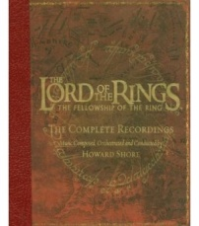
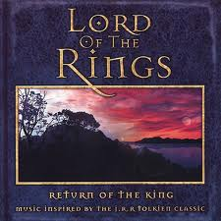
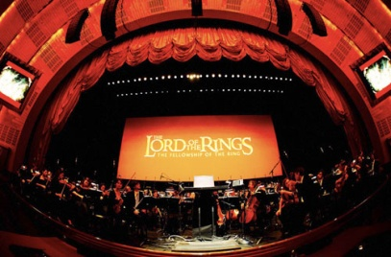
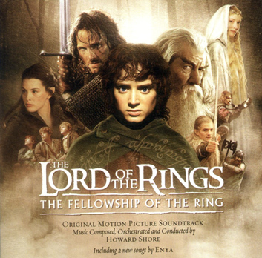
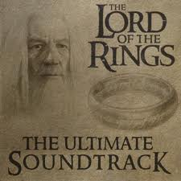
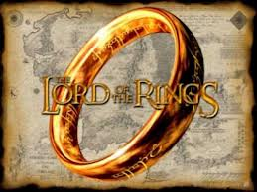
List of motifs in The Lord of the Rings
Mise-en-Scene
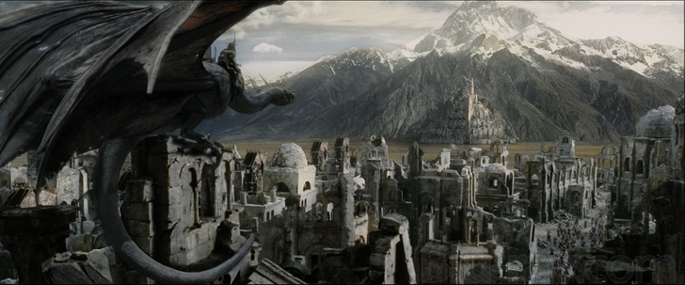
Mise-en-scéne is an expression used to describe what appears in front of the camera including the set, the props, the actor(s), the costumes and the lighting. Each director usually has a certain style in his/her movie and this term is used to help show the difference between each movie as a whole. For example if two directors made a movie out of the same script, they would not necessarily end up looking anything like each other. In the Lord of the Rings, Peter Jackson uses New Zealand for most of his landscapes and sets and he used clever casting to cast tall slender people as elves, stockier people for Dwarves and curly haired people who could imitate country accents for hobbits therefore the Mise-en-scene is very dramatic with huge landscapes and each race is very defined by certain characteristics.
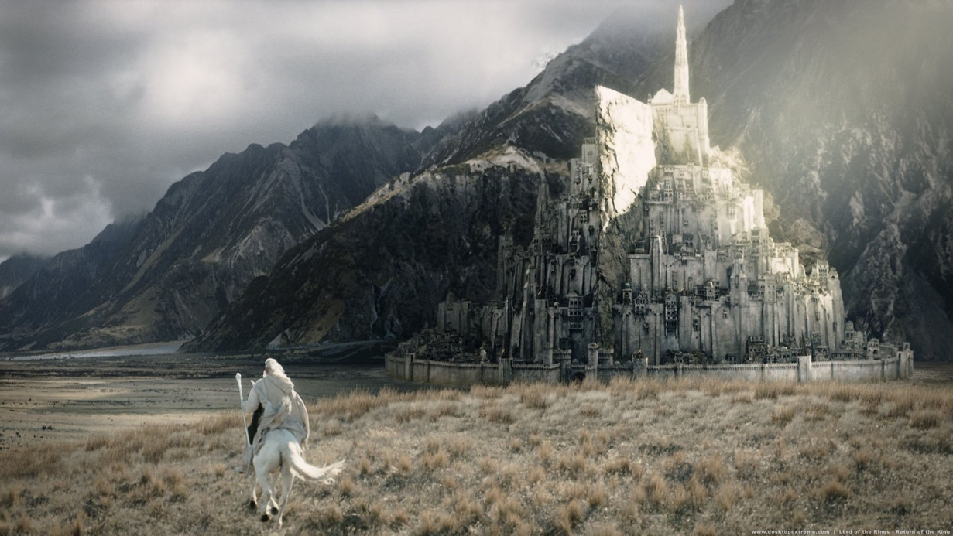
Actors and Acting
Acting is one of the most important parts of cinema. You could have a fantastic film ruined just by casting bad actors so, naturally, in a film as big as The Lord of the Rings; you have to choose very carefully. In my opinion they chose extremely well and I can’t think of a single actor who I would change and because there are so many important characters, that is really saying something!
List of Main Cast
Sean Astin | Sam | Sean Bean | Boromir
Cate Blanchett | Galadriel | Orlando Bloom | Legolas
Billy Boyd | Pippin | Bernard Hill | Théoden
Ian Holm | Bilbo | Ian McKellen | Gandalf
Dominic Monaghan | Merry | Viggo Mortensen | Aragorn
John Noble | Denathor | Miranda Otto | Éowyn
John Rhys-Davies | Gimli | Andy Serkis | Gollum/Smeagol
Liv Tyler | Arwen | Karl Urban | Éomer
Hugo Weaving | Elrond | David Wenham | Faramir
Elijah Wood | Frodo | Harry Sinclair | Isildur
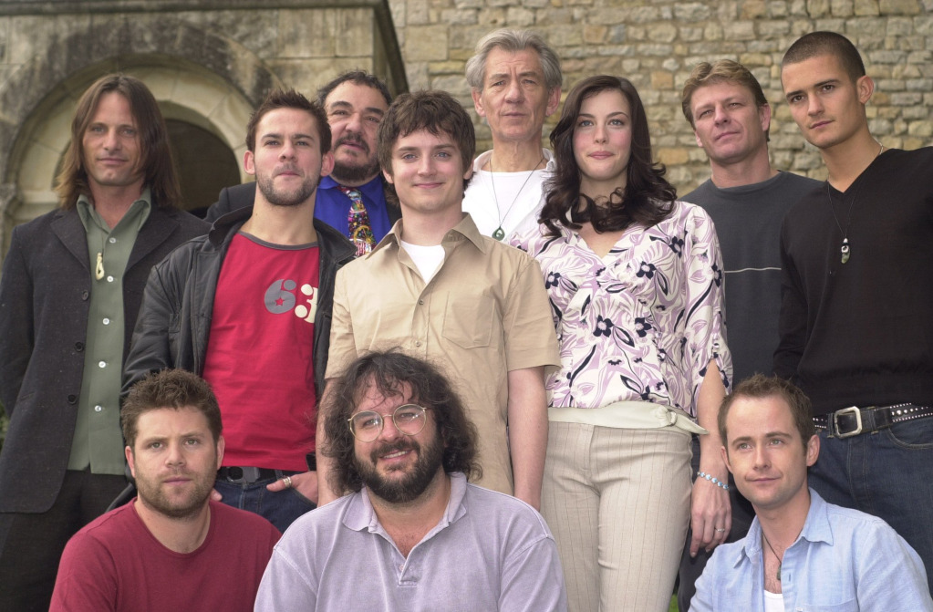

Special effects
Special effects are ways that we can show whole new worlds without having to build or do everything in real life. There would be no way to make a film about magic or alien spaceships etc without visual effects because we can’t film them for real.
In the Lord of the Rings, special effects are key to the overall film-making process. In fact there were 1,488 shots using special effects in this movie alone. For example in war scenes it would be impossible to hire that many extras and put make up and costumes on them all and it would be very hard to find actors the size of hobbits and Dwarves.
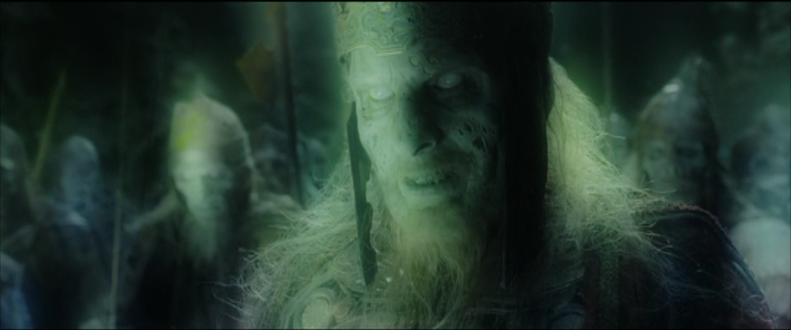
One of the best examples of special effects in this film is the King of the Dead and his army. The King himself was an actor with prosthetics and a costume but he was made to look ghostly with visual effects. Also in that scene is his army which is completely digitally made.
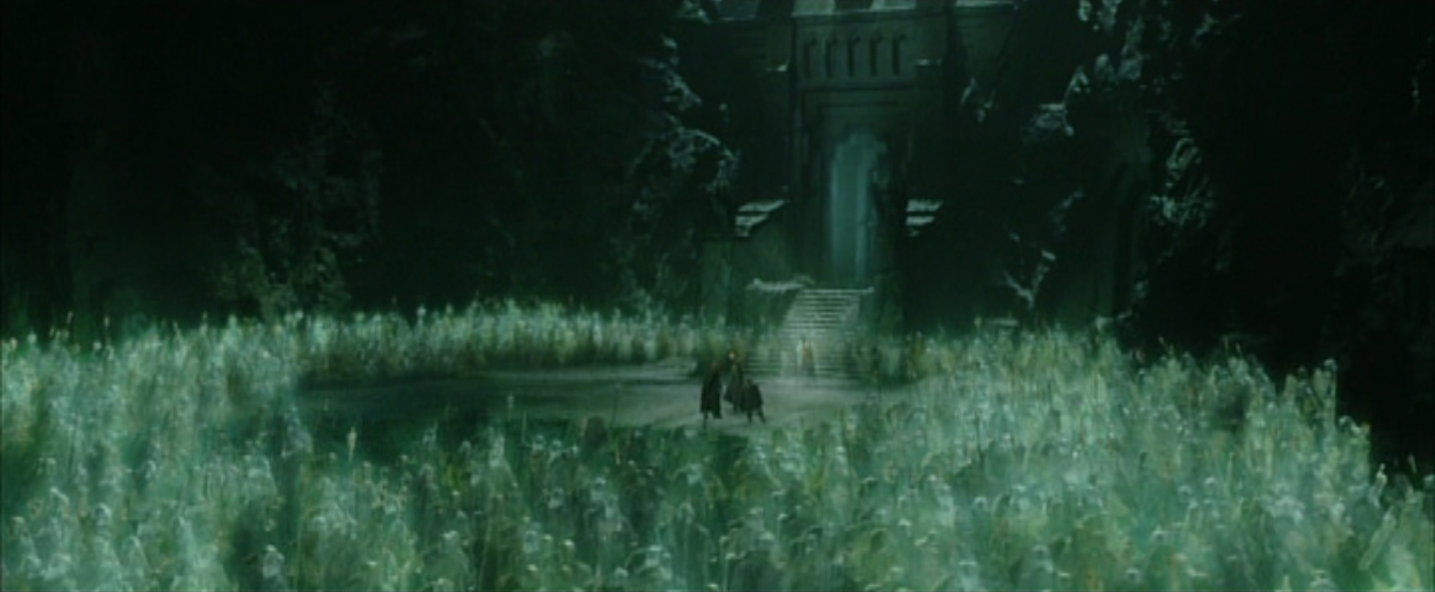
Cinematography and artistic design
Cinematography is the art of shooting film. The cinematographer makes the decisions on how to shoot a scene, from where and what lighting will be used. They make artistic design choices while filming. In the silent movie era, the cinematographer was the key person on set because there was only the camera, the lighting and the acting.
In the Lord of the Rings: Return of the King, the cinematographer is Andrew Lesnie. He would be in charge of where each shot is and what lighting is used for it.
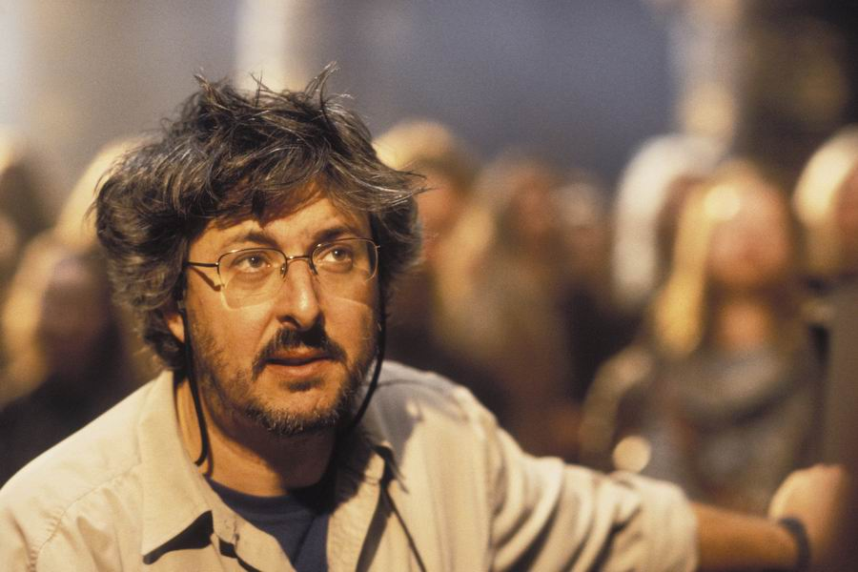
Make-up and Hair Design
Make-up and Hair Design are both essential to most movies out today because it is part of an actor’s costume. It is a very important factor in the Lord of the Rings: Return of the King because prosthetics are used on so many characters. They are used on all of the orks, the King of the Dead and many more. There are many different types of creature in these films and each of them have very distinctive features which help identify them as a member of that race and most of this is bone by using hair and make-up. For example the Hobbits have curly hair, the Dwarves have lots of facial hair and the elves have long hair and unblemished faces.
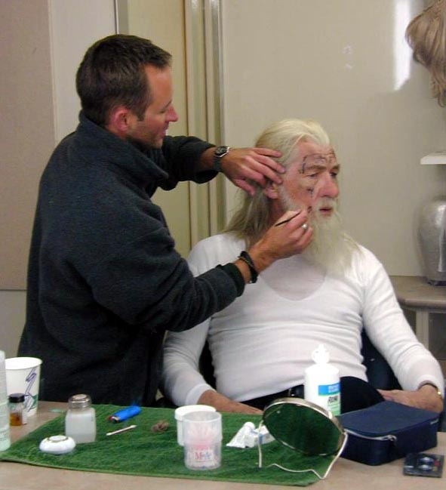
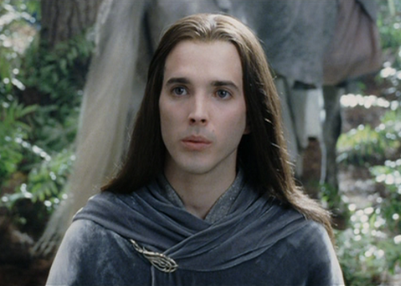
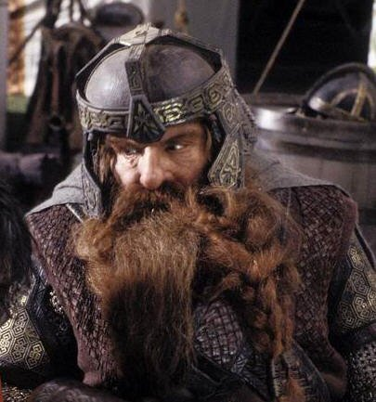
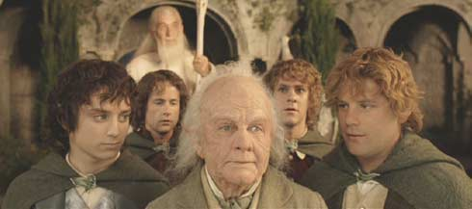
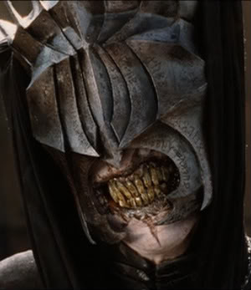
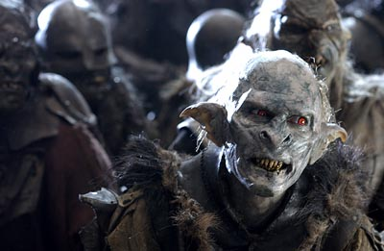
Sequencing
Sequencing is the art of putting a film together so that it flows well and is both interesting to look at and it creates atmosphere.
My favourite example of this is the scene where Denethor asks Pippin to sing him a song while Faramir, Denathor’s son, is trying to take back Osgiliath. The mixture of the two scenes is incredible because it gets a message across.
If you want to watch the clip, the link is below. Otherwise I have taken screenshots of most of the shots in the clip and put them on the next page. It is worthwhile watching this clip for the music in the background.
http://www.youtube.com/watch?v=45WXQZ8-tPc

Film Review: “The Lord of the Rings: Return of the King”
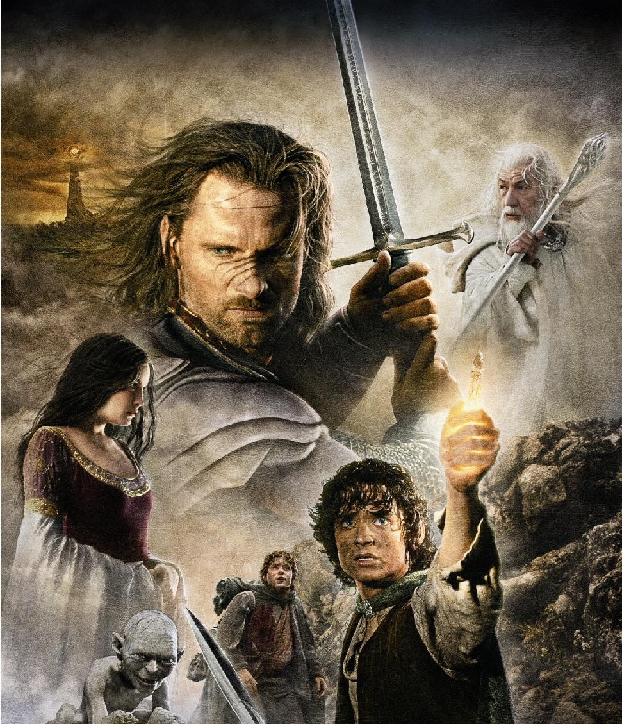
The Lord of the Rings: Return of the King is the third in a trilogy of movies about middle-earth, a fantasy world, where the races of elves, men, Dwarves, Hobbits and a few wizards live peacefully alongside one another. However the one ring of Sauron, (the evil demon who was destroyed by Isildur) that holds all of his power has been found by a Hobbit and someone has to take it to the fires of Mount Doom where it was made, in order to be destroyed to prevent Sauron from getting it back. That someone is Frodo Baggins accompanied by the fellowship of the ring. After the fellowship is split it is up to Frodo and Sam and Gollum to take the ring to Mordor. Meanwhile Middle-earth is facing the armies of Mordor and with the elves passing into the west it is up to mankind to protect the world from the Orks and Uruk-hai of Sauron.
This film is full of plot and suspense. It grabs your attention and pulls you in until you are wrapped up in the characters and the plot. It is a simply unmissable film not only for it’s plot and acting, which are both amazing, but for the sets, the landscapes, costumes, sequencing, Make-up, Hair and prosthetics, special effects, music, lighting and Sound effects. Each of these is done to the finest degree and it was honestly a pleasure to study academically! I would recommend this to anyone with a bit of patience (because despite all of it’s charms is pretty long) and I would give it 10/10.

